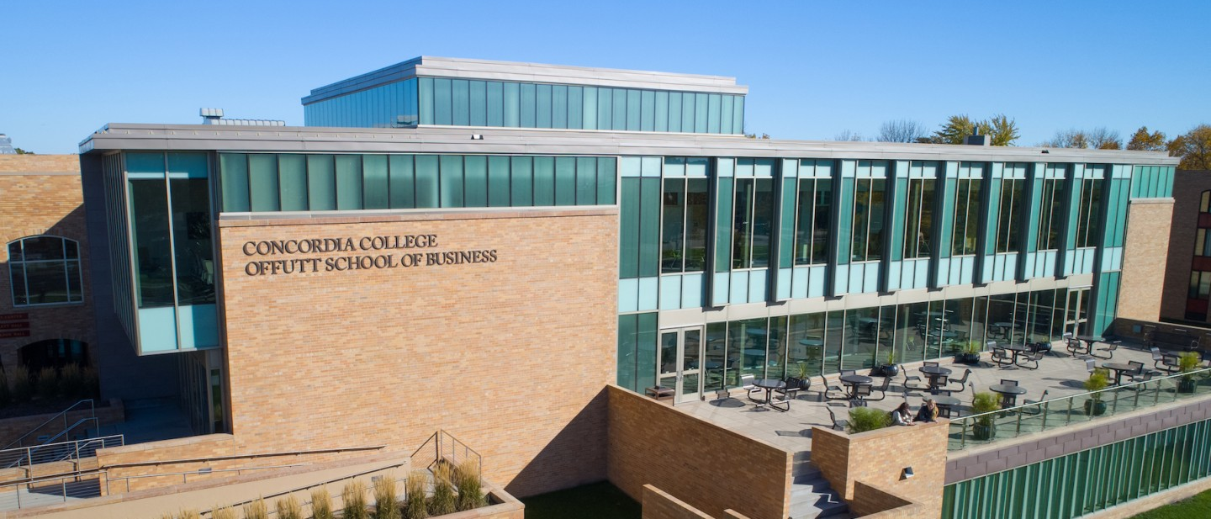

Project Proposal

|  |
| --- |
| The Cobber RPG |

|  |  |
| --- | --- |
| Course | **CSC 225 – Fundamental Structures** |
|  | |
| Team Name | **Office Heroes** |
|  |  |
| Team Members | **Jaleta Fanta Tesgera** |
|  | **Segni Tadele Tulu** |
|  | **Ye Yint Win** |

|  |
| --- |
| Executive Summary |
| Your executive summary should resemble an elevator pitch: your motivation is to quickly persuade a decision maker to get involved in your project.  What is the purpose of your project? What problem(s) does it address?  To know more about Concordia College through a game. Students don’t know a lot about the buildings of the college as they only have to attend classes in some of the buildings and incoming students as well due to the weather and COVID restrictions.  Why is your project important? Why is it relevant?   * Due to covid, freshmen students are not getting the full in-person experience of Concordia campus. * It can help assist incoming students and faculties to get to know more about Concordia. * It can help new ambassadors to know more about Concordia and put their knowledge to the test(game). * It can serve as a base for anyone who wants to know more about Concordia. |

|  |
| --- |
| Background and Problem History |
| Explain the problem domain and relevant background information about your project.  Provide a brief history of the problem; when did it start? What attempts have been made to solve it?  The Concordia website did not give specific information about the campus.  The students did not have a good knowledge of the campus and what which building is for. |

|  |
| --- |
| Solution |
| How does your team plan to solve the problem?  COVID pandemic has impacted current and incoming students to get to know about Concordia College and campus giving an interactive virtual tour.  What makes your approach different from other solutions?  We are going to give more interactive and gaming-like experiences for people. There is going to be inside knowledge and experiences. |

|  |
| --- |
| Project Deliverables |
| What will be the “product” of your team’s project? What documents will you create?  A program that is going to give a 2-d, virtual tour of the campus.  After a virtual tour and study the user is prompted to take the quiz of executing missions by Niblet/Kernel.  A power point presentation where we pitch the mockup and design of our project. |

|  |
| --- |
| Success Criteria |
| How will your team define success? What aspects of your project can you quantify to objectively measure success?  Success is achieving our goals, that’s when the faculty and students start to use this software.   * Accurate presentation of the Concordia campus map on 2-d. * Have Niblet/Kernel Moving around * Make a tour and a game as well. * Being able to give inside information from Students and student ambassadors. |

|  |
| --- |
| Challenges |
| What obstacles or challenges might your group face?   * In our view the map we used is just a sample so, it may not indicate the actual or real experience. * Being a Beginner coders * Time insufficient to do the whole codes * The codes might be too much to handle. * We don’t have a running Interface yet. |

|  |
| --- |
| List of Required Project Resources and Materials |
| What resources (books, websites, data sets, problem domain information sources, software, etc.) will be required to complete your project?  Initial Sources we assumed:   * Concordia Map * Information from students * Google map * Stack Overflow * Prof. Damian Lampl * Resources from the internet as needed.   Sources we used for the Presentation (MLA Citation):  *Kernel and Niblet*. (2007, October 4). Concordia College. <https://www.concordiacollege.edu/about/concordia-traditions/kernel-and-niblet/>  *Free Transparent Background Maker | Adobe Creative Cloud Express*. (2010, December 30). Adobe. <https://www.adobe.com/express/feature/image/transparent-background>  *Yahoo is part of the Yahoo family of brands*. (2012, December 12). Yahoo Sports. <https://sports.yahoo.com/ncaaf/teams/concordia-(ala)/?guccounter=1&guce_referrer=aHR0cHM6Ly93d3cuZ29vZ2xlLmNvbS8&guce_referrer_sig=AQAAAJ5NBvksqnFqk9aK5RMiyRcOPUZcUxBHo7bEoWnYnDutackcKmkg1lu_IBaWT99VyKcpZW7lnhjm8jikjn8I4qFFx_M3hsB0cZcP9tkKSASZwjH2LcWxHHJh4Mom1dM_XKC-m-qvFja8VznJ5VEBAXZC5IzkrA-pFb_7NLaRChqz>  *Facebook - Meld je aan of registreer je*. (2017, November 16). Facebook. <https://www.facebook.com/unsupportedbrowser?_rdr>  *Concordia Now*. (2018, November 31). Concordia College. <https://www.concordiacollege.edu/about/now/>  Concordia College. (2018, June 25). <https://www.concordiacollege.edu/about/%E2%80%8B>  CobberNet.  (2016, March 14).<https://bprdeis.cord.edu:8443/authenticationendpoint/login.do?commonAuthCallerPath=%252Fcas%252Flogin&forceAuth=false&passiveAuth=false&tenantDomain=carbon.super&sessionDataKey=139abc2a-43ec-4c95-8a13-271a1238e7c2&relyingParty=cobbernet&type=cassso&sp=cobbernet&isSaaSApp=false&authenticators=BasicAuthenticator:LOCAL>  Apps we used:   * Microsoft Paint * Google maps (Plain and Satellite Image) |